12 Editors - Compositor
Compositor Editor 2
Navigating in the Compositing Editor viewport 2
Hotkeys 2
Preview Image in nodes 3
Node context menu 3
Duplicate 3
Rename 3
Delete 3
Copy 3
Paste 3
Delete with Reconnect 4
Make Links 4
Make and Replace Links 4
Detach Links 4
Group 4
Ungroup 5
Edit Group 5
Hide 6
Toggle Node Mute 6
Toggle Node Preview 6
Toggle Hidden Node Sockets 6
Toggle Node Options 6
Collapse and Hide Unused Sockets 6
Quick Favorites menu 7
Hotkey only functionality 7
Back image Sample - Alt Right Mouse 7

Compositor Editor
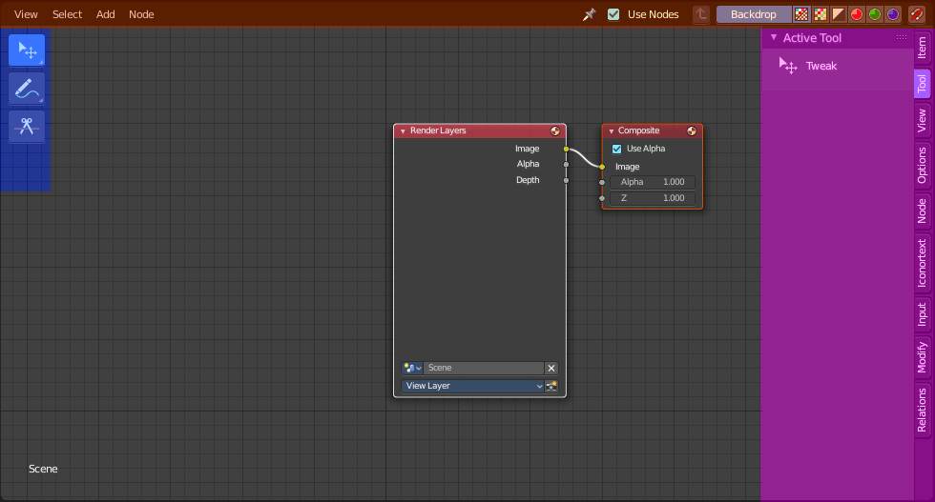
The Compositing editor allows you to do compositing. This means to modify and combine image layers in many different ways and by lots of available nodes. You can glue two pieces of footage together, colorize a whole image sequence at once and do all the traditional compositing steps that you usually would do in a 2d software.
The editor is divided into several areas.
Yellow – Header
Blue - Tool Shelf
Pink - Sidebar
Note that the editor does not have a tool area above the header. All tool settings are in the sidebar in the Tool tab.

Navigating in the Compositing Editor viewport

Hotkeys
Pan the view - MMB
Zoom - Mouse Wheel, MMB+CTRL, Numpad + / -
View All - Home

Preview Image in nodes

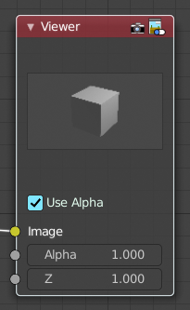
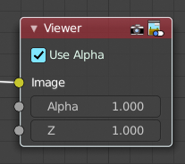
Some nodes has two icons up right. The right icon is a button that allows you to expand the node and to show a preview image.

Node context menu

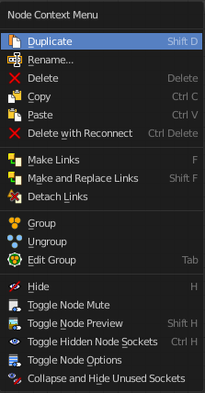
When you double right click into the viewport, then you will open a menu. The UV Context menu. Its content is to 100% double content to already existing menus. And it is despite the name not contextual.

Duplicate
Duplicates the selected nodes.

Rename
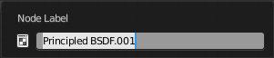
Allows you to rename the current active node. A popup opens up where you can type in another name.

Delete
Deletes the selected nodes. All Connections gets removed.

Copy
Copies the selected nodes.

Paste
Pastes the copied nodes.

Delete with Reconnect
Deletes the selected nodes. Existing connections gets bypassed as if the node would not have existed.

Make Links
Tries to connect nodes where it makes sense. For example, the BSDF output of a Principled shader with the Surface input of the Material Output node.

Make and Replace Links
Same as Make Links. But it will replace existing links.

Detach Links
Removes all connections from the selected node, but tries to reconnect the remaining nodes.

Group
Groups the selected nodes together.
Select the nodes that you want to group together. Choose Make Group. You will now see a green background. This indicates that the group is created, and that you are in edit mode for the group now.



To exit the group edit mode press Tab key, or choose Toggle Edit Group menu item in the sidebar in the Relations tab in the Group panel. That way you can also enter the Group Edit mode again.




There is a third way to enter the group edit mode. Click at the right upper icon of the group node.


A group can be further collapsed by clicking at the triangle button in the upper left corner.


The group can be renamed in the sidebar in the Item tab and in the Properties tab in the Node panel.

Ungroup
Removes the selected nodes from a group.

Edit Group
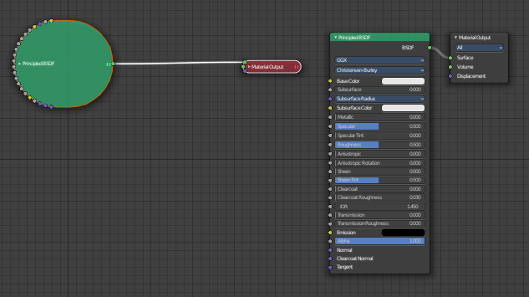
Edits a group of nodes.

Hide
Collapses the node display. Left hidden, right the original nodes.

Toggle Node Mute
Makes the current selected node active or inactive. This feature does not work with the material output node.

Toggle Node Preview
No idea. It is not to find out what gets previewed under what circumstances. And the feature is not to find in the Blender manual.

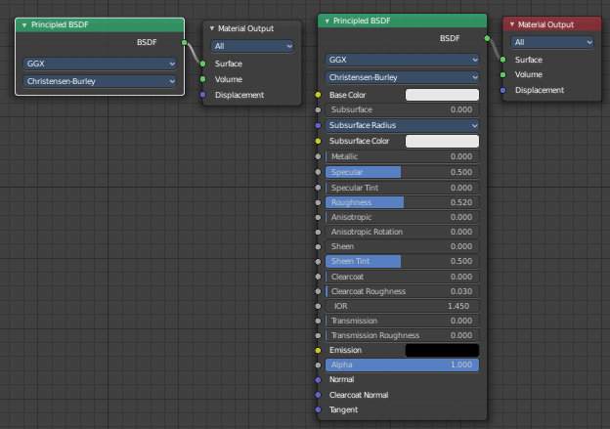
Toggle Hidden Node Sockets
Shows or hides the node sockets.

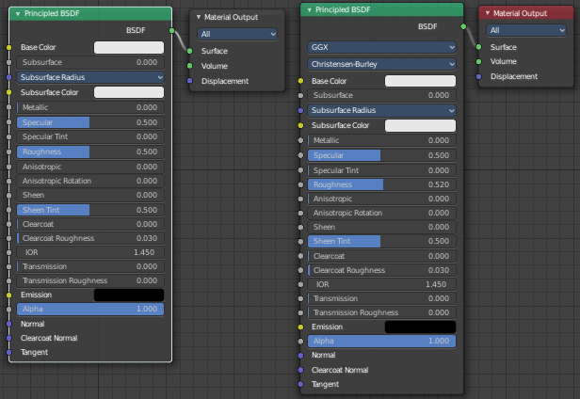
Toggle Node Options
Shows or hides the node options.

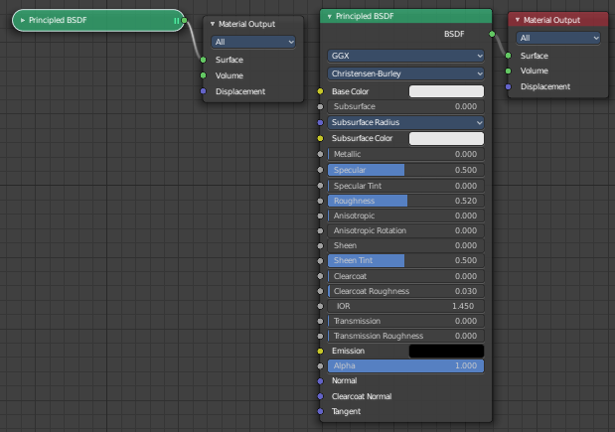
Collapse and Hide Unused Sockets
Shows or hides unused sockets.

Quick Favorites menu


When you right click at a menu or a button, then a right click menu will open. Tools have usually a Add to Quick Favorites menu entry.

The Quick Favorites Menu is empty by default. With Add to Quick favorites you can add this menu to the Quick menu.

In the 3D view we have a menu called Quick in the header, which shows this content then. In the Image Editor you can just call it with its hotkey. Q. It has no regular menu entry here.

Hotkey only functionality

Important! These hotkeys works with the default Bforartists key map And they do not list the Ndof hotkeys. Ndof is a 3d connexion mouse device that is also used for tablets.
Most of the tools can be found in the graphical UI. But there are still some tools that are hotkey only. Some have a UI brother with equal functionality. For example, Pick shortest path is the hotkey sister of Select shortest path. Some are hotkey only since they cannot be integrated in the graphical UI. Like calling the File menu under the mouse. Or mouse position dependent functionality like selecting an edge loop.
The navigation hotkeys and the context menus are excluded here since they are already covered.

Back image Sample - Alt Right Mouse
Displays the color information of the Background Image under the current mouse position. Position, RGB Values, HSV, etc. . You need to have a Viewer node in the compositing chain, and the background image must show.

